Instructions for getting access to TSU.Account (Russian: ТГУ.Аккаунт), Moodle Platform and Personal Account
TSU.Account allows to login to the Personal Account (https://lk.student.tsu.ru/) and the Moodle platform (http://moodle.tsu.ru/)
Access to TSU.Account
If you have already signed up for TSU.Account but can’t remember your password, go to https://accounts.tsu.ru/ and select forgot password button (Russian: Забыли пароль) (fig.1). Then enter your email address and click Send (Russian: Отправить). After that you will receive a password reset email (check the Spam and Junk Mail folder)
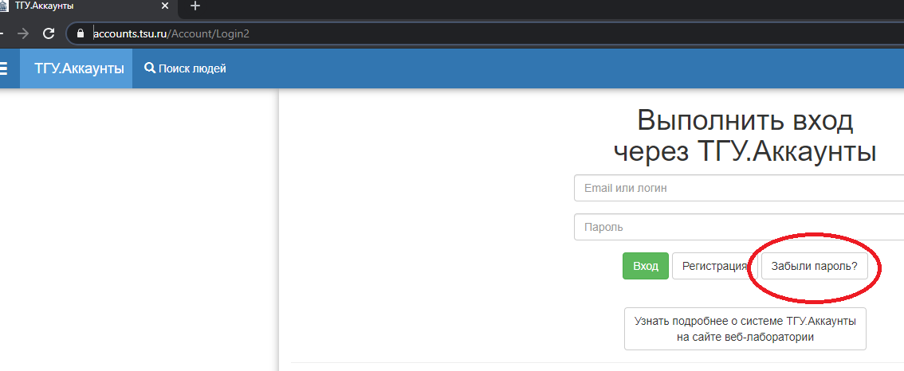Figure 1 – Forgot password button

If you didn’t manage to restore access yourself, please contact Service Desk for assistance support@accounts.tsu.ru. The email must contain the following information: full name, date of birth, faculty and group number, attached scan or photo of identity verification document (high quality images) (passport, student ID, ID, etc.).
Access to Moodle platform
You should have TSU.Account to get access to Moodle. Follow a link http://moodle.tsu.ru/ to login to the platform. Click Log in (Russian: Вход) button and then click Sign in with TSU.Account (Russian: Войти через ТГУ.Аккаунт) (fig.2 and fig.3).
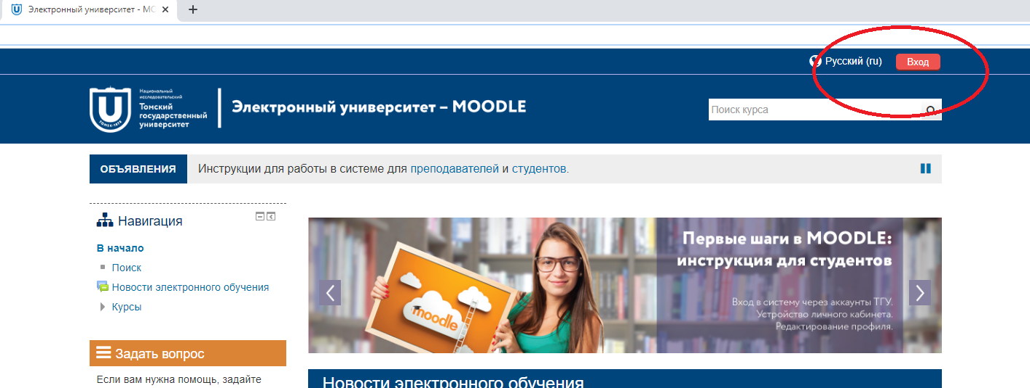
Figure 2 – Log in button

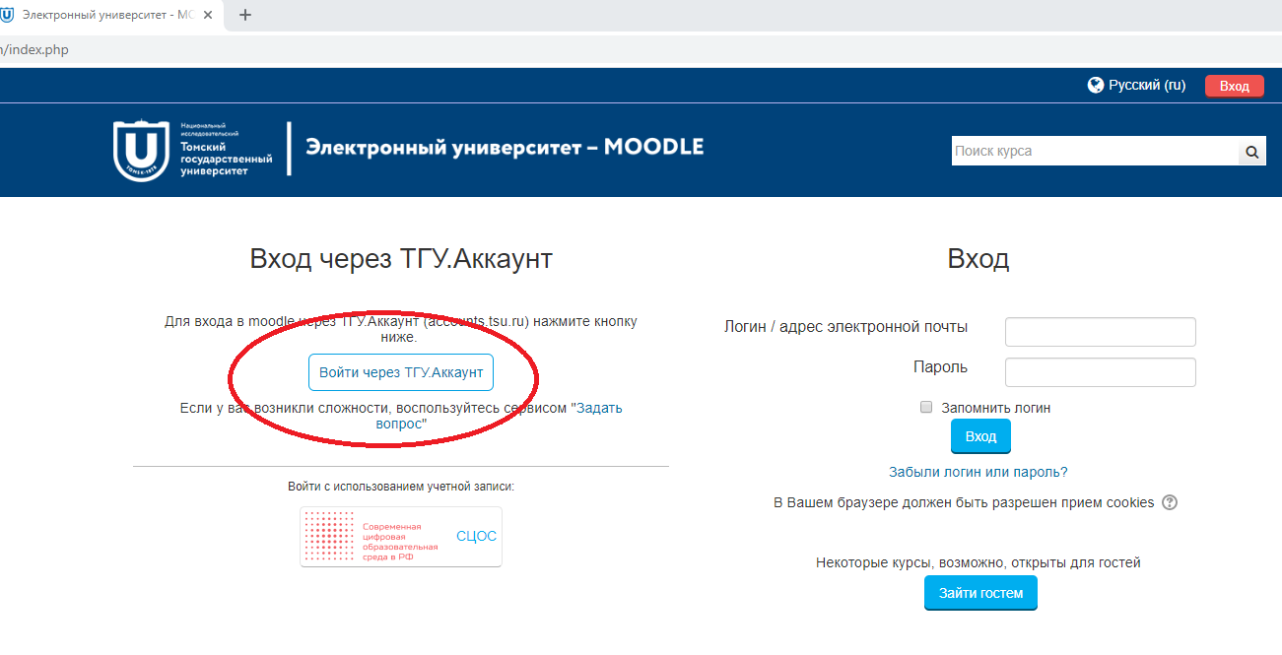
Figure 3 – Sign in with TSU.Account button

If you didn’t manage to sign in with TSU.Account, please contact Service Desk for assistance support@accounts.tsu.ru. The email must contain the following information: full name, date of birth, faculty and group number, attached scan or photo of identity verification document (high quality images) (passport, student ID, ID, etc.).
Access to Personal Account
To access your Personal Account https://lk.student.tsu.ru/ you should have a validated TSU.Account.
You can use your Personal Account to see information about your studies, get necessary documents (http://web.tsu.ru/en/poluchenie-spravki-ob-obuchenii). After logging in the website, you can view your academic performance, curriculum, research activities, and your document requests. For postgraduate students there is an opportunity to fill out a personal curriculum and print scholastic records (Russian: Аттестационные ведомости).
TSU.Account Validation
To validate your TSU.Account, it is necessary to send scans of your passport and a signed application for TSU.Account validation to support@accounts.tsu.ru (sample application can be found on http://web.tsu.ru/en/podtverzhdenie-tsu-account) using the email address indicated in your TSU.Account.
Please note that in order to access the Moodle platform, it is not necessary to validate the account!

